Title

Author Name¹, Author Name², initials then surnames, separated by commas

¹First author’s address, email address
²Second author’s address, email address

Full papers shall be limited to between 6-8 A4 pages (including figures, tables and references).

Abstract

Briefly specifying the aims of the work, the main results obtained, and the conclusions drawn. No more than 100 words.

Keywords: Keyword 1; Keyword 2; Keyword 3; Keyword 4; Keyword 5; Keyword 6

- Introduction – (Major headings are typed 12pt Times New Roman bold)

The text is typed 12pt Times New Roman and justified, with no indent. Insert one line space between paragraphs.

The introduction section should present the scope and objective of the paper and state the problem, briefly review the pertinent literature, describe the methods, and provide an overview of the main results of the work.

For citation in the main text, use surname of author and year of publication: Holtz (1968) or (Holtz, 1968). The abbreviation "et al." should be used in the text when there are more than two co-authors of a cited paper.

- Material and Methods

The methods/techniques must be clearly stated and described in sufficient detail or with sufficient references.

  - Minor headings

Minor headings are typed 12pt Times New Roman bold, with no indent. Only the first letter of the first word should be upper case, other word should be lower case. Insert one line space between paragraphs.

An example of table layout is shown in Table 1. It shows the dimensions of the text area to be used. Note that a minimum number of horizontal rules and (usually) no vertical rules are used. Make sure all tables will fit inside the text area.

Table 1. Raw water and permeate values
Parameter | Unit | Raw Water | UF Permeate
Turbidity | NTU | 23 | 0,1
TOC | mg/L | 5,7 | 4,3
Total Coliform | cfu/100 mL | 160 | 0

Figures should be embedded correctly positioned within your Word file (Figure 1). In line with text adjustments is recommended. Make sure all figures will fit inside the text area.

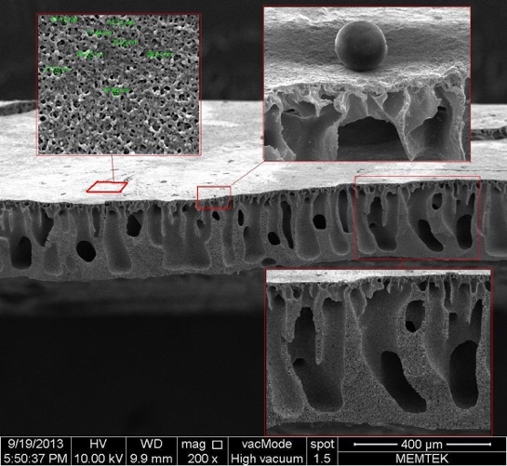
Figure 1. SEM image of membrane cross section

- Results and Discussion

The experimental results obtained or the major outcomes of the performed study should summarize clearly in this section. Any trends or points of interest should be highlighted and their significance explained.

- Conclusions

Give brief explanation of the significance and implications of the work reported, and highlight any “take-home message” you wish to deliver.

Acknowledgements
This section is optional. Please use 10 pt text size and format as shown here.

References

Please use 10 pt text size and format as shown here.

Pabby, A.K., Sastre, A.M., (2008). Hollow fiber membrane-based separation technology: Performance and design, Book Chapter 4, Taylor & Francis Group, LLC, page 92-135 (Book Section)
(URL-1) <http://www.cheresources.com/content/articles/separation-technology/hollow-fiber-membranes?pg=3>, date retrieved 30.10.2012 (Web Page)
Rugbani, A., (2009). Investigating The Influence of Fabrication Parameters on the Diameter and Mechanical Properties of Polysulfone Ultrafiltration Hollow-Fibre Membranes, MSc. Thesis, University of Stellenbosch. (Thesis)
Ma, H., Burger, C., Hsiao, B.S., Chu, B. (2012). Highly Permeable Polymer Membranes Containing Directed Channels for Water Purification, ACS Macro Lett., 1: 723−726. (Article)

